PROJECT REPORT – HRMS & ATTENDANCE MANAGEMENT SYSTEM

Project Overview
This system is a Complete Human Resource Management Solution designed to automate Employee Management, Attendance Tracking, Leave & Permission Workflows, Salary Advance & Loan Processing, and Payroll Generation.
Here we have divided this module in to 3 simplified major modules. They are as follows
- Attendance
- User Management
- Payroll System
Let’s deep dive into these 3 modules sequentially.

1. Attendance Module (5 days)
This module explores the main functionality of the software and where our payroll engine will start with this ignite only that is attendance of all the employees. Here we will take the biometric device logs for to calculate the attendance for the employees in this process we have divided the this major module into sub-modules. They are listed below
- Shift control
- Permission module
- Leaves
- Over time supervision

Shift Control
The Shift Control Module is responsible for managing and assigning shifts across various departments within the organization. As our industry operates under multiple shift patterns, this module allows administrators to create, modify, and allocate department-specific shifts.
It also supports pre-scheduling, real-time shift detection from employee attendance logs, and provides mechanisms to resolve shift ambiguities through HR/HOD intervention.

Objectives
- Efficiently manage diverse shift patterns across departments.
- Automatically determine an employee’s shift based on attendance logs.
- Provide flexibility to pre-assign shifts.
- Handle late-ins, early-outs, and shift conflicts systematically.
- Enable HR/HOD to manually resolve ambiguous shift cases.

Key Features
Feature | Description
Shift Creation & Management | Allows creation of multiple shift templates (e.g., Morning, Afternoon, Night) with attributes like start time, end time, grace period, and working hours.
Department-wise Shift Allocation | Shifts can be linked to specific departments, ensuring only relevant shift options appear for their employees.
Automatic Shift Detection | Based on the employee’s in-time and out-time logs, the system determines the most likely shift.
Grace Time Handling | Employees arriving within a defined grace period (e.g., 15 minutes) are still considered on time.
Conflict Resolution | In case of multiple possible shifts (due to late entry or overlapping times), the system flags the record for HOD/HR review.
Pre-scheduling | HR or HOD can assign predefined shifts to employees in advance (daily or weekly).
Attendance Integration | Automatically calculates attendance, late-ins, early-outs, and total working hours based on confirmed shifts.

Process Flow

1. Shift Assignment
- HR/HOD creates or selects a shift template.
- Assigns the shift to a department or specific employee.
- Optionally, pre-schedules future shifts.

2. Employee Log Processing
- System captures the employee’s in-time and out-time from the attendance device/log.
- Identifies the employee’s department and fetches the related shifts.

3. Shift Determination
- The system checks which shift window matches the employee’s in-time (considering 15 min grace).
- If a clear match is found → shift is auto-assigned.
- If multiple shifts are possible → record is marked as “Confused” and sent to HR/HOD for manual resolution.

4. Manual Resolution (If Required)
- HR/HOD reviews confused entries.
- Selects the correct shift based on in/out times, lateness, or early departure.
- Confirms and finalizes shift allocation.

5. Attendance Calculation
- Once shift is finalized, system computes:
  - Total working hours.
  - Late-ins or early-outs (if any).
  - Attendance status for payroll or analytics.

Use Case Scenarios

Use Case 1: Auto Shift Detection
Flow:
- Employee punches in at 8:05 AM.
- System checks department “Production,” which has Morning (8 AM – 4 PM) and Night (8 PM – 4 AM) shifts.
- With a 15-minute grace period, the 8:05 AM punch falls within Morning shift.
- Shift auto-assigned → attendance marked accordingly

Use Case 2: Confused Shift Detection
Flow:
- Employee punches in at 8: 30 AM.
- Grace period exceeded → system cannot clearly map to Morning or General shift.
- Record flagged as Confused Shift.
- HOD manually reviews logs and assigns the correct shift.
- Attendance recalculated accordingly.
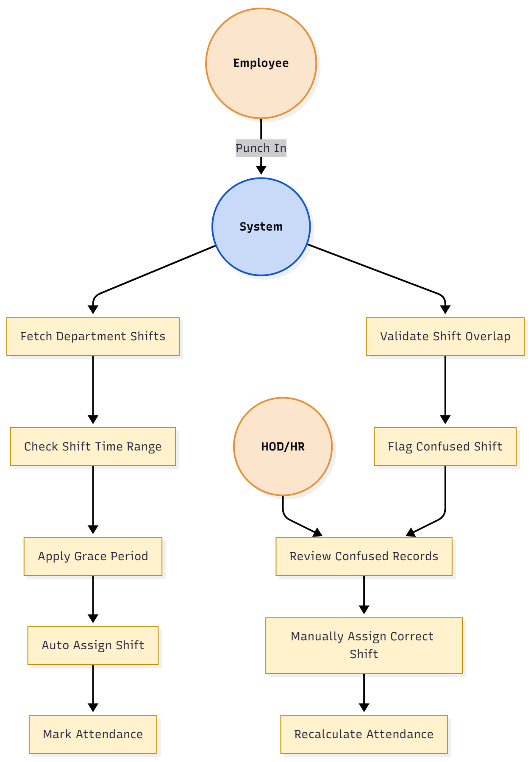

Use Case 3: Pre-Scheduled Shifts
Flow:
- HR pre-schedules “Night Shift” for employees of Maintenance Dept for the next day.
- When employees log in, the system directly matches their entries against pre-assigned shifts.
- Shift detection and attendance processed seamlessly.

Flow Diagram:
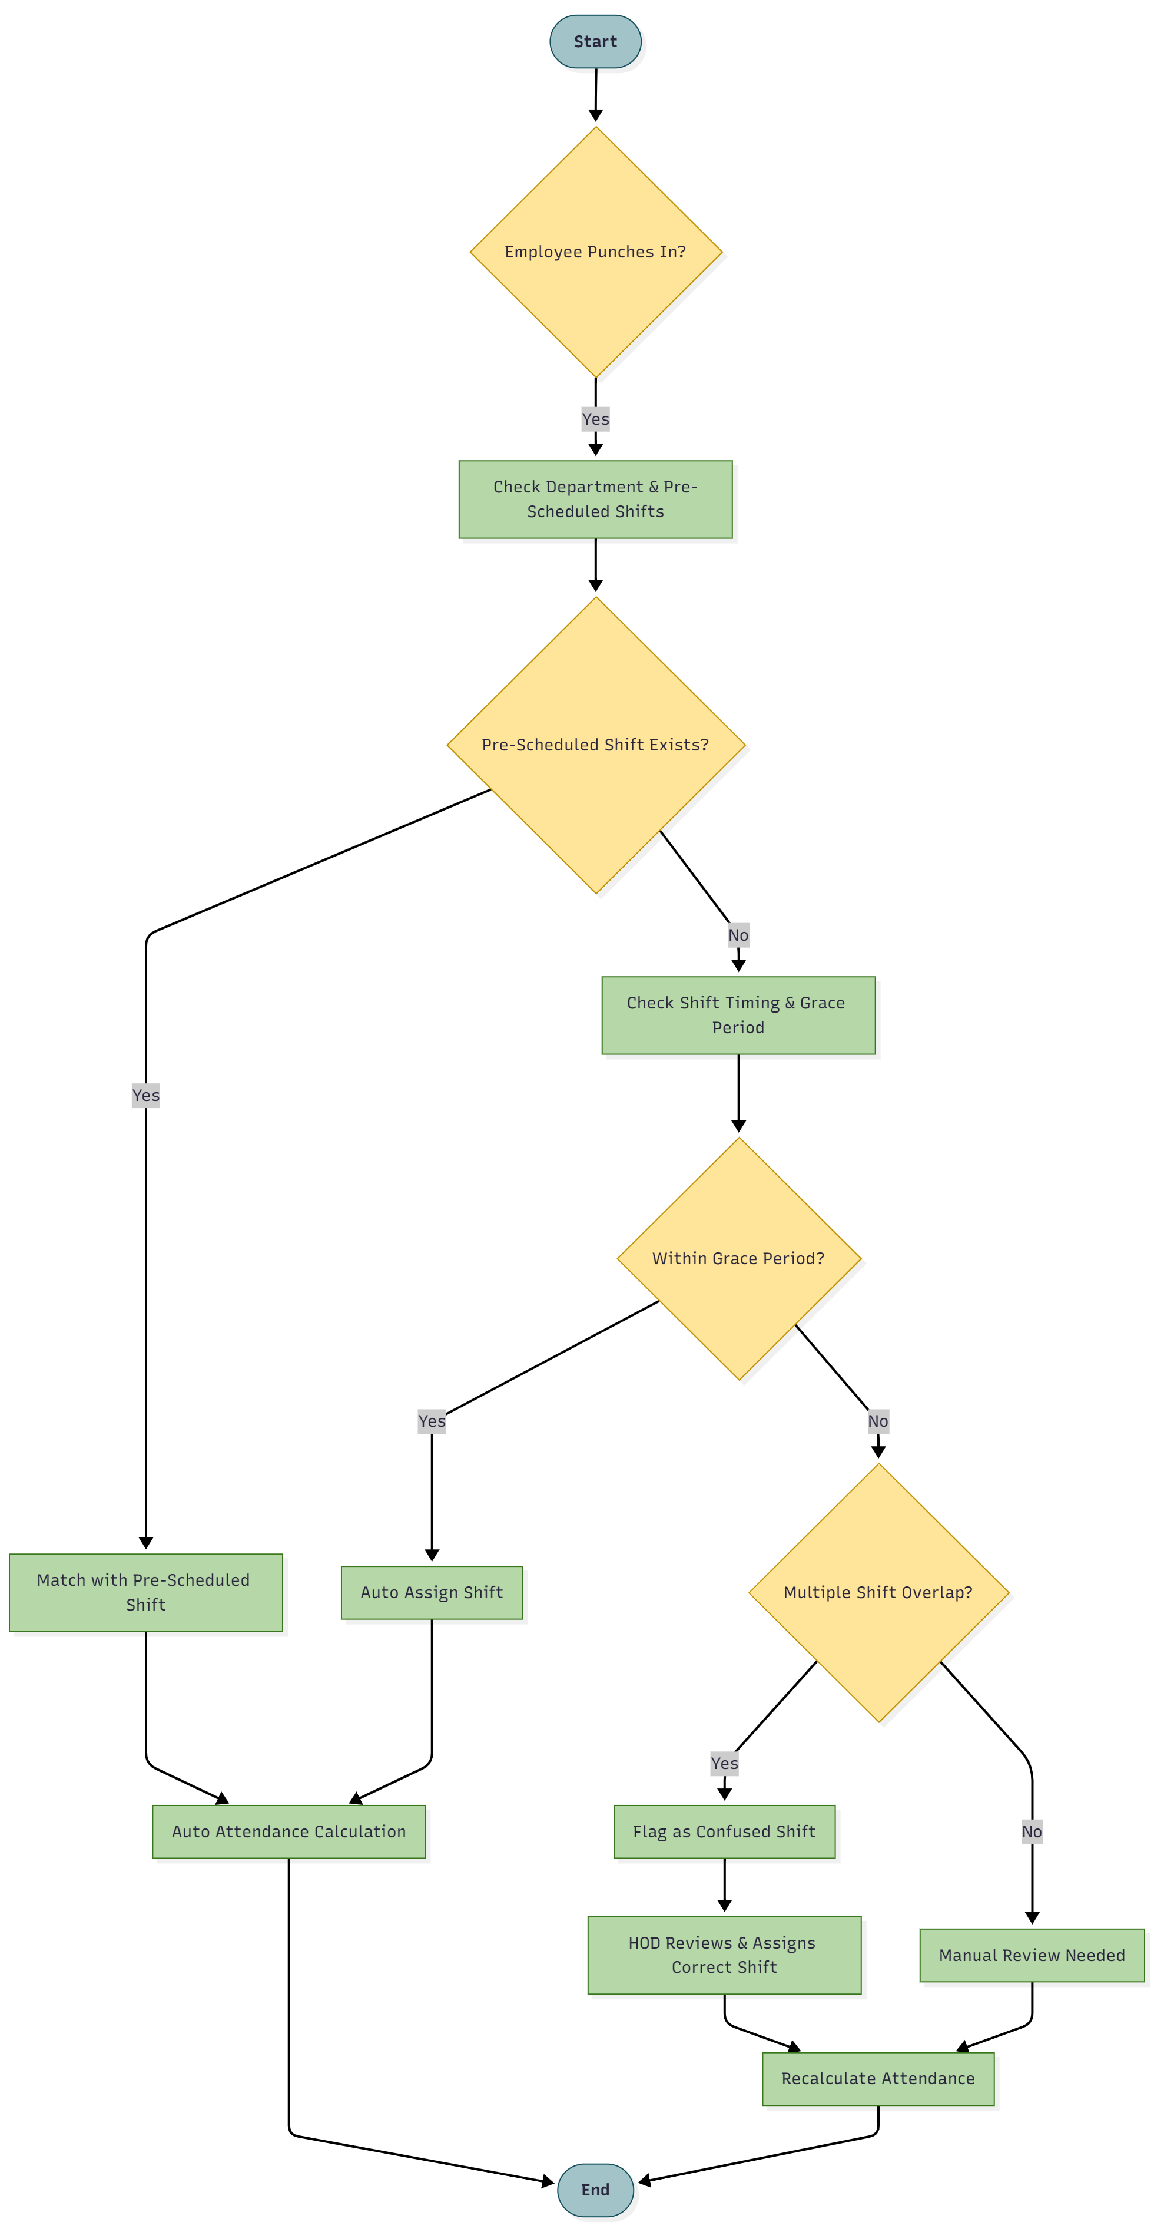

1.1.5 Benefits
- Reduces manual intervention through automation.
- Ensures accuracy in attendance and payroll computation.
- Provides transparency for shift-related conflicts.
- Improves operational efficiency in multi-shift environments.

Leave, Permission, Over Time & On Duty Workflow Module

The Leave, Permission, On-Duty & Overtime Workflow Module manages all employee absence and extra working hour processes through a configurable approval system.
It includes management of leave types, on-duty assignments, and overtime requests, with multi-level approvals and payroll integration. This ensures that all employee attendance-related actions are tracked, authorized, and reflected accurately in salary computation and workforce planning.

1.2.1 Workflow
Employee / HOD Apply → HOD Approval → HR Approval → (Optional) Super Admin Final Approval
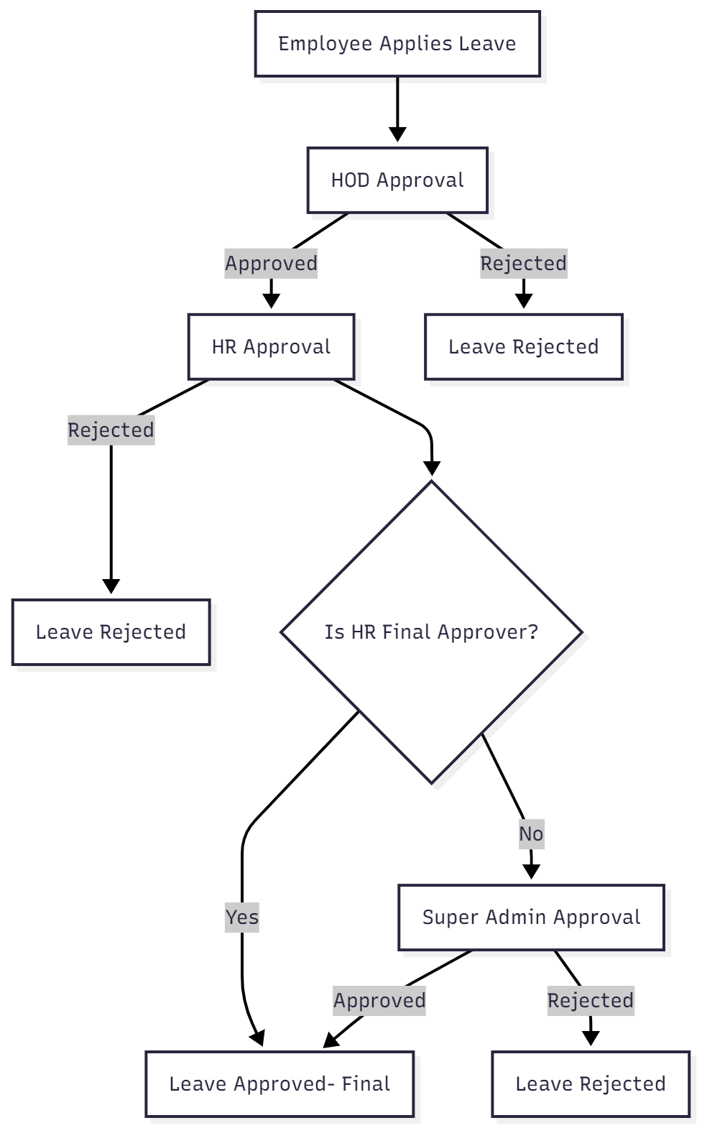
This flow can be configured based on organizational needs. If the Super Admin disables the “Final Approval” layer, HR’s decision will be treated as final.

1.2.2 Key Features
Feature | Description
Configurable Approval Hierarchy | Multi-level workflow for Leave, OD, and OT approval — customized by organization policy.
Leave Type Management | Super Admin or HR (based on permission) can create, modify, and assign leave types such as Casual, Sick, Paid, Unpaid.
On-Duty (OD) Management | Enables employees or HODs to mark official duties performed outside the workplace. Approved OD entries count as present for that day.
Overtime (OT) Requests | HOD can apply OT for employees, specifying employee name, overtime end time, reason, and purpose.
Auto Overtime Detection | If HR does not approve OT on the same day, the system auto-calculates extra time worked beyond shift hours and flags it for review.
Department/Designation OT Pay Settings | HR/Super Admin can configure overtime payment rates (per hour) by department or designation.
Department Leave Limits | Restrict how many employees per department can take leave on a given day; allows override for emergencies.
Payroll Integration | All approved Leave, OD, and OT records are integrated into monthly payroll.
Role-based Permissions | Super Admin decides if HR can manage (CRUD) leave types and OT/OD configurations.

1.2.3 Process Flow

1. Leave Type Configuration
- Super Admin configures whether HR can manage leave types.
- Based on this, either Super Admin or HR performs CRUD operations on leave types (e.g., Casual, Sick, Paid, etc.).
- Each leave type is linked with payroll behaviour (paid/unpaid) and applicable rules.

2. On-Duty (OD) Application
- Employee or HOD applies for OD specifying date, purpose, and location.
- OD follows the standard approval workflow (HOD → HR → Super Admin).
- Once approved, OD is treated as present for that day.

3. Overtime (OT) Application
- HOD initiates an OT request mentioning:
  - Employee(s) involved
  - Overtime end time
  - Reason and purpose for extra work
- HR reviews and approves based on policy and workload.

4. Auto Overtime Detection
- If HR does not approve OT manually on the same day:
  - The system calculates extra hours worked beyond the employee’s assigned shift.
  - Marks the day with “Auto-detected OT” status.
  - HR can later review and approve or reject the auto-detected OT entry.

5. Leave Application
- Employee or HOD submits a leave/permission request with details (type, date, reason, attachments if any).
- The system validates against:
  - Leave balance
  - Departmental limit
  - Existing pending requests

6. Approval Workflow
- Stage 1 – HOD Approval
  - HOD reviews and either approves/rejects the request.
  - Upon approval, the request moves to HR.
- Stage 2 – HR Approval
  - HR verifies leave type validity, availability, and department constraints.
  - Approves or rejects based on policy.
- Stage 3 – Super Admin (Optional)
  - If configured, final approval lies with Super Admin for sensitive or high-level requests.

5. Payroll Impact
- Once approved, leave data is automatically integrated into payroll.
- Paid leaves → counted as working days.
- Unpaid leaves → deducted from monthly salary.
- Leave without pay (LWP) is flagged for HR payroll processing.
- Approved Leave, OD, and OT entries automatically affect:
  - Attendance records
  - Salary computation
  - Reports & analytics dashboards

1.2.4 Use Case Scenarios

Use Case 1: On-Duty Request

Flow:
- Employee/HOD applies OD with date, place, and reason.
- HOD approves → HR verifies → Marked as OD day.
- Attendance marked as “Present (On-Duty)”.

Use Case 2: HOD-Initiated Overtime Request
Flow:
- HOD selects employee, enters OT end time, reason, and purpose.
- HR reviews and approves.
- System adds OT hours to payroll with department-specific hourly rate.

Use Case 3: Auto Overtime Detection
Flow:
- Employee’s out-time exceeds shift end by 1 hour.
- System auto-flags “1 hour extra worked.”
- HR reviews and approves/rejects.
- If approved, pay reflected in payroll.

Use Case 4: Standard Leave Request
Flow:
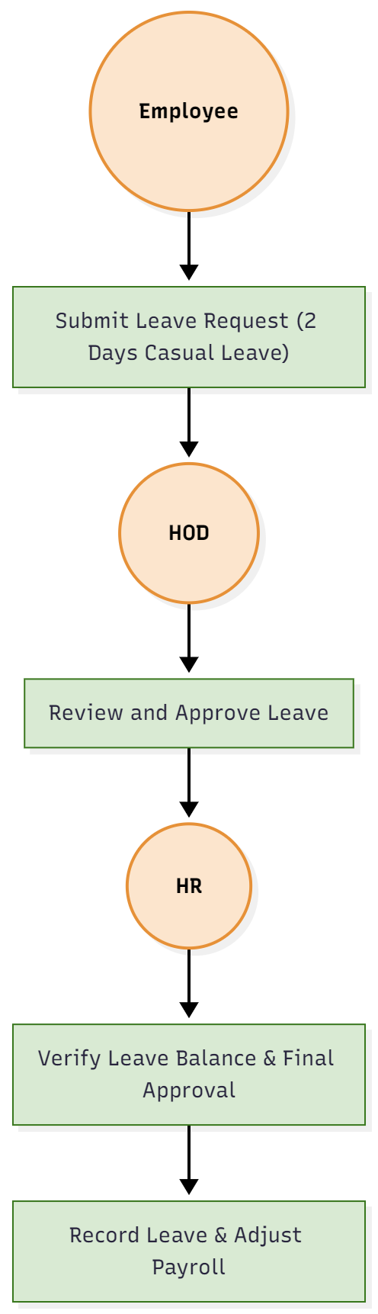
- Employee submits a leave request via portal.
- HOD approves the request.
- HR verifies balance and approves.
- Leave is recorded and payroll adjusted accordingly

Use Case 5: Emergency Leave Beyond Department Limit
Flow:
- Department has a daily limit of 3 leaves.
- Fourth employee requests emergency leave.
- System alerts “Limit exceeded” but allows override.
- HOD/HR explicitly approves.
- Leave marked as “Emergency Approved” for record.
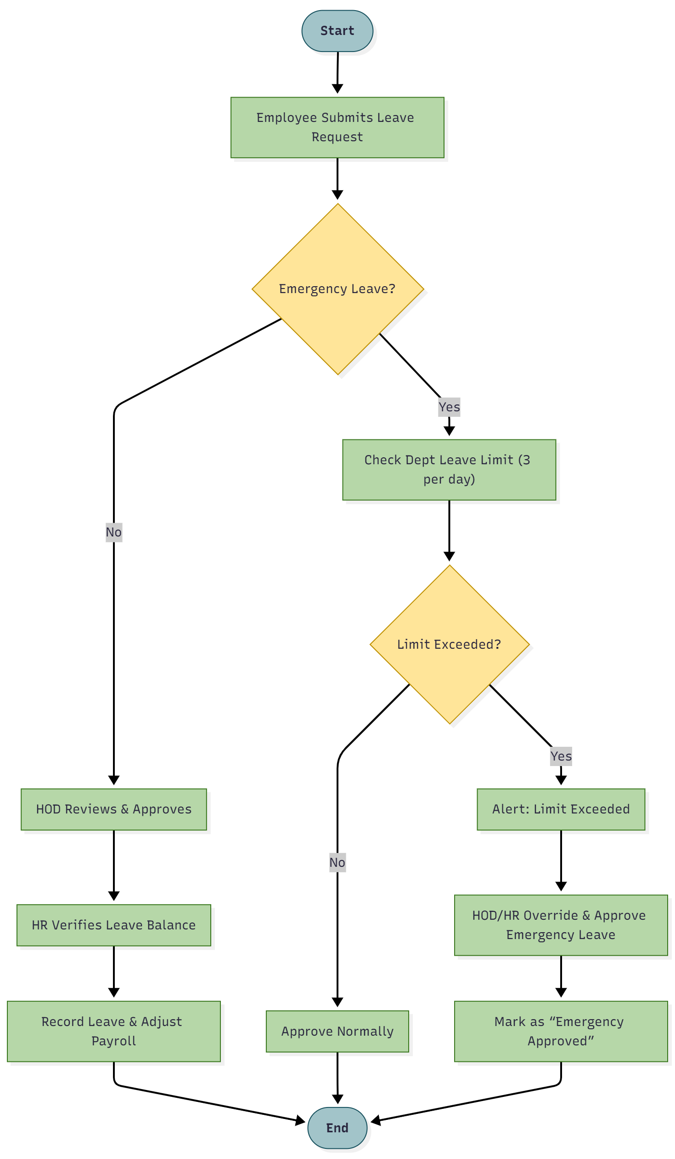

2. User Management (2 days)

The User Management Module serves as the central control system for defining roles, managing access permissions, and configuring departmental-level settings.
This module ensures that every user (Super Admin, Sub-Admin, HR, HOD, and Employee) has well-defined responsibilities, permissions, and access scopes.
It also allows organization-wide configuration of departmental rules such as late-ins, early-outs, permissions, and attendance deductions, ensuring consistent enforcement of HR policies across all units. In this process we have dived this into 2 submodules. They are as follows

- User & Role Management
- Department Management & Configuration

2.1 User & Role Management
The User & Role Management sub-module is responsible for creating, assigning, and controlling user access based on their roles within the system.
It enforces a structured role hierarchy and provides the flexibility for multi-role assignments (e.g., an employee can act as HOD, HR, or Sub-Admin based on configuration).

2.1.1 Objectives
- Centralize user and role-based access management.
- Define clear role hierarchies and permissions (Read/Write access).
- Provide flexibility to map multiple roles to a single employee (e.g., Employee as Sub-Admin or HR).

2.1.2 Key Features
Feature | Description
User Creation | Super Admin can create Sub-Admins, HRs, HODs, and Employees.
Role Assignment | Assigns one or multiple roles to a single user (e.g., Employee as HR).
Access Configuration | Defines Read/Write access per module for Sub-Admins.
Dynamic Hierarchy | Allows flexible reporting structures (e.g., HR under Sub-Admin, multiple HODs per department).
Profile Management | Edit, deactivate, or delete users as needed.
Audit Logging | Maintains record of all role assignments and changes for security tracking.

2.1.3 Process Flow

1. Role & Access Definition
- Super Admin defines modules accessible to Sub-Admins (with Read or Write access).
- Configures HR permissions and departmental scope.
- Assigns HODs and maps them to respective departments.

2. User Creation
- Super Admin creates new users and assigns roles.
- Role configuration determines access visibility in the UI (e.g., sidebar items available).

3. Role Extension
- In special cases, employees can be promoted or assigned additional roles such as HR, HOD, or Sub-Admin for specific departments.

2.1.4 Use Case Scenarios

Use Case 1: Sub-Admin Creation
Flow:
- Super Admin opens User Creation → selects Sub-Admin role.
- Assigns Read/Write access for required modules.
- Sub-Admin created with permissions dynamically reflected on dashboard.

Use Case 2: Assign Employee as HOD
Flow:
- Super Admin selects department.
- Chooses employee from list → assigns HOD role.
- Department mapped to that employee as HOD.

Use Case 3: HR Configuration
Flow:
- Super Admin opens HR Configuration Settings.
- Toggles “Allow HR to manage Leave Types / Department Configurations.”
- HR privileges updated accordingly.
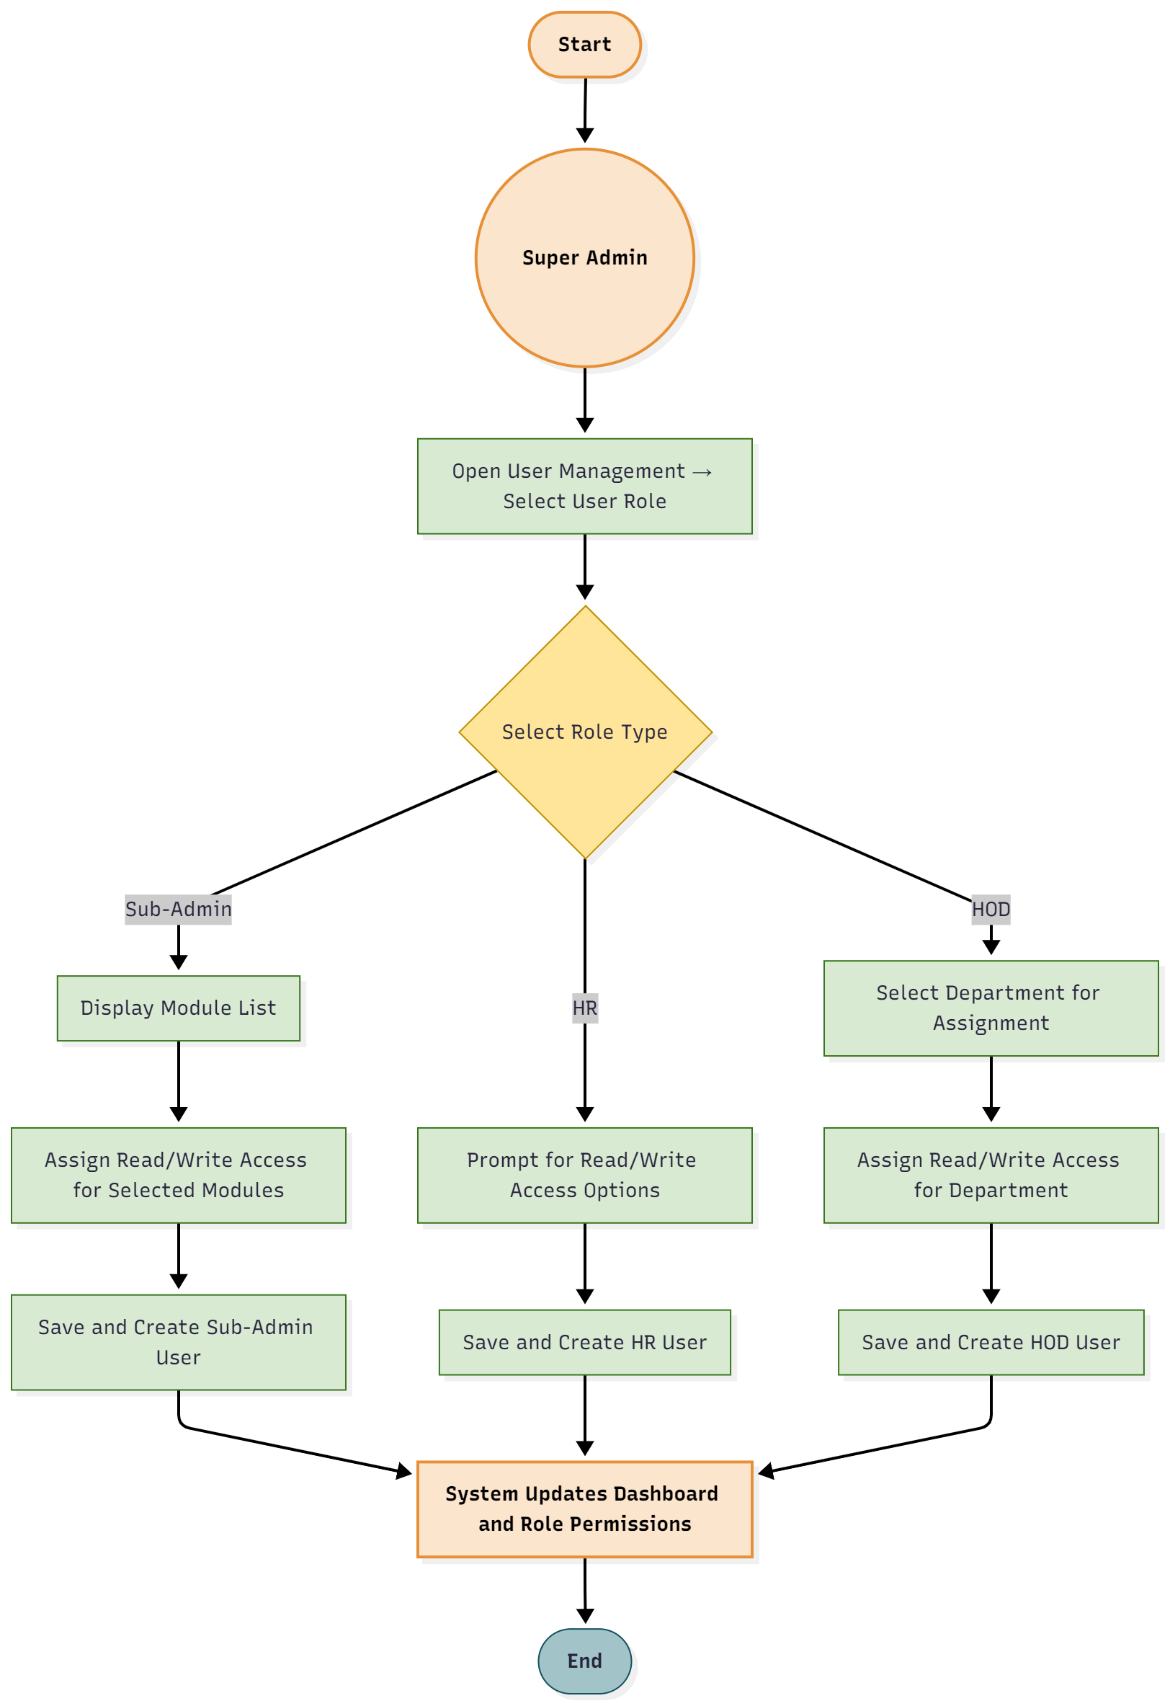

2.2 Department Management & Configuration
The Department Management & Configuration sub-module is responsible for managing departments, assigning department heads (HODs), and setting department-specific HR policies.
All attendance-related configuration such as late-ins, early-outs, and permission deductions are managed here.

2.2.1 Objectives
- Manage department structures and assign HODs, HRs, and employees accordingly.
- Configure department-level attendance and permission rules.

2.2.2 Key Features
Feature | Description
Department CRUD | Create, edit, delete, and view departments.
Assign HOD/HR | Assign department HOD and HR from existing employee list.
List Department Employees | View and manage all employees within a department.
Late-In / Early-Out Configuration | Define how many late-ins or early-outs are allowed before triggering deductions.
Permission Policy Configuration | Set daily/monthly permission limits and their payroll impact.
Auto-Deduction Rules | Define actions after exceeding limits (e.g., 3 late-ins = half-day deduction).
Department Settings Dashboard | Unified interface to manage department-level attendance and permission policies.

2.2.3 Process Flow

1. Department Creation
- Super Admin or authorized HR creates new departments.
- Assigns department code, name, and related configuration template.

2. Role Assignment
- Assign an existing employee as HOD for the department.
- HR can also be mapped to a department if permitted by the Super Admin.

3. Configuration Setup
- Define attendance rules:
  - Allowed late-ins / early-outs.
  - Deduction thresholds (e.g., 3 late-ins → ½ day deduction).
  - Permission count and duration per employee.
- Save and apply configuration to all employees in that department.

4. Monitoring & Update
- HR can view department employee lists and configuration summaries.
- Super Admin can modify or override department configurations anytime.

2.2.4 Use Case Scenarios

Use Case 1: Department Creation & Configuration
Flow:
- Create new department (e.g., Production).
- Assign HOD and HR.
- Configure late-in limit (3 times/month) and penalty (½ day deduction).
- Save settings — automatically applied to department employees.

Use Case 2: Permission Limit Configuration
Flow:
- HR opens Department Settings → Permissions.
- Defines “Max 3 permissions/month.”
- Adds “After 3, each permission = ¼ day deduction.”
- Saved settings auto-apply for payroll processing.
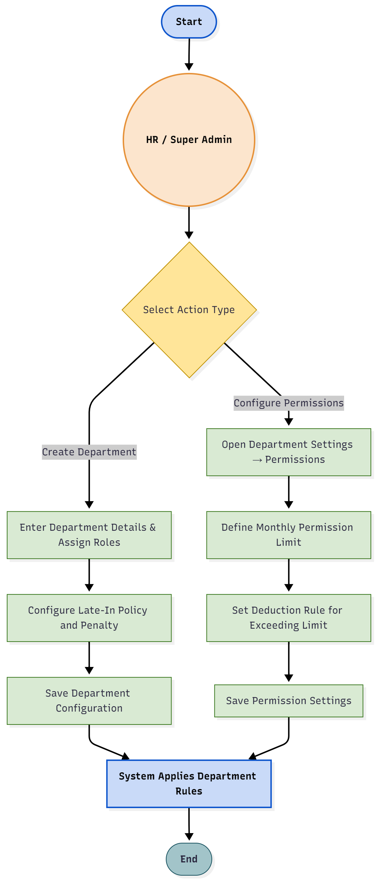

3. Payroll Management System (4 days)
The Payroll Management System is a comprehensive module responsible for automating employee salary calculation, managing allowances, deductions, overtime payments, and handling loans or salary advances.
It integrates directly with the Attendance & Shift Control module to process attendance-based salary computation and provides complete transparency for HR, HOD, and Super Admin to review payroll details before final disbursement. In this Process we have divided it in the 2 sub modules they are as follows
- Payroll Engine
- Loan & Salary Advance Workflow
The Payroll system ensures:
- Accurate salary computation based on attendance and overtime
- Department-wise and employee-specific configuration for allowances/deductions
- Automatic EMI and salary advance reconciliation
- Transparent approval workflow for financial requests (loan/advance)
- Comprehensive salary slip and transaction recording

3.1 Payroll Engine
The Payroll Engine is the core computational system of the payroll module.
It automatically processes attendance data, calculates salaries, applies deductions and allowances, and generates the gross and net salary for each employee.

3.1.1 Flow of Payroll Calculation
- Data Gathering
  - Fetch the attendance report of the employee for the month.
  - Retrieve fixed salary details from the employee profile.
  - Collect department-level configurations (allowances, deductions, overtime rates).
- Gross Salary Calculation
  - Basic Pay: Calculated based on the employee’s fixed salary and total working days.
  - Allowances: Department-wise or employee-specific allowances applied; if not configured, default allowances are used.
  - Overtime Calculation:
    - Total overtime hours = Time worked beyond the assigned shift.
    - Overtime pay = (Overtime Hours × Rate per Hour) based on department/designation configuration.
  - Gross Salary = Basic Pay + Allowances + Overtime Pay
- Deductions & Attendance Adjustments
  - Deductions include:
    - Department/employee-specific deduction rules
    - Late-ins, early-outs, permissions (as per HR configuration)
  - The formula used for attendance-based deduction:
  - Deduction Amount = ((Days to Deduct) / (Total Working Days)) × Basic Pay
Where Days to Deduct may include late-ins/early-outs and permission deductions as per configured rules.
- Loan and Salary Advance Adjustments
  - Loan EMI Deduction:
    - Retrieve the employee’s active loans.
    - Deduct the monthly EMI from the payable salary.
    - Update the loan record: reduce remaining EMIs and outstanding balance.
  - Salary Advance Adjustment:
    - Check if a salary advance is pending.
    - Deduct the advance amount from the payable salary.
    - If advance > payable amount → salary becomes zero, and remaining advance is carried forward.
    - If advance < payable → balance paid to employee, and remaining advance cleared.
- Net Salary Calculation
  - Net Salary = Gross Salary − (Deductions + Loan EMI + Advance Adjustment)
- Transaction Logging & Record Update
  - Store all payroll transactions (credits, deductions, EMI, advances).
  - Update the employee’s payroll history for that month.
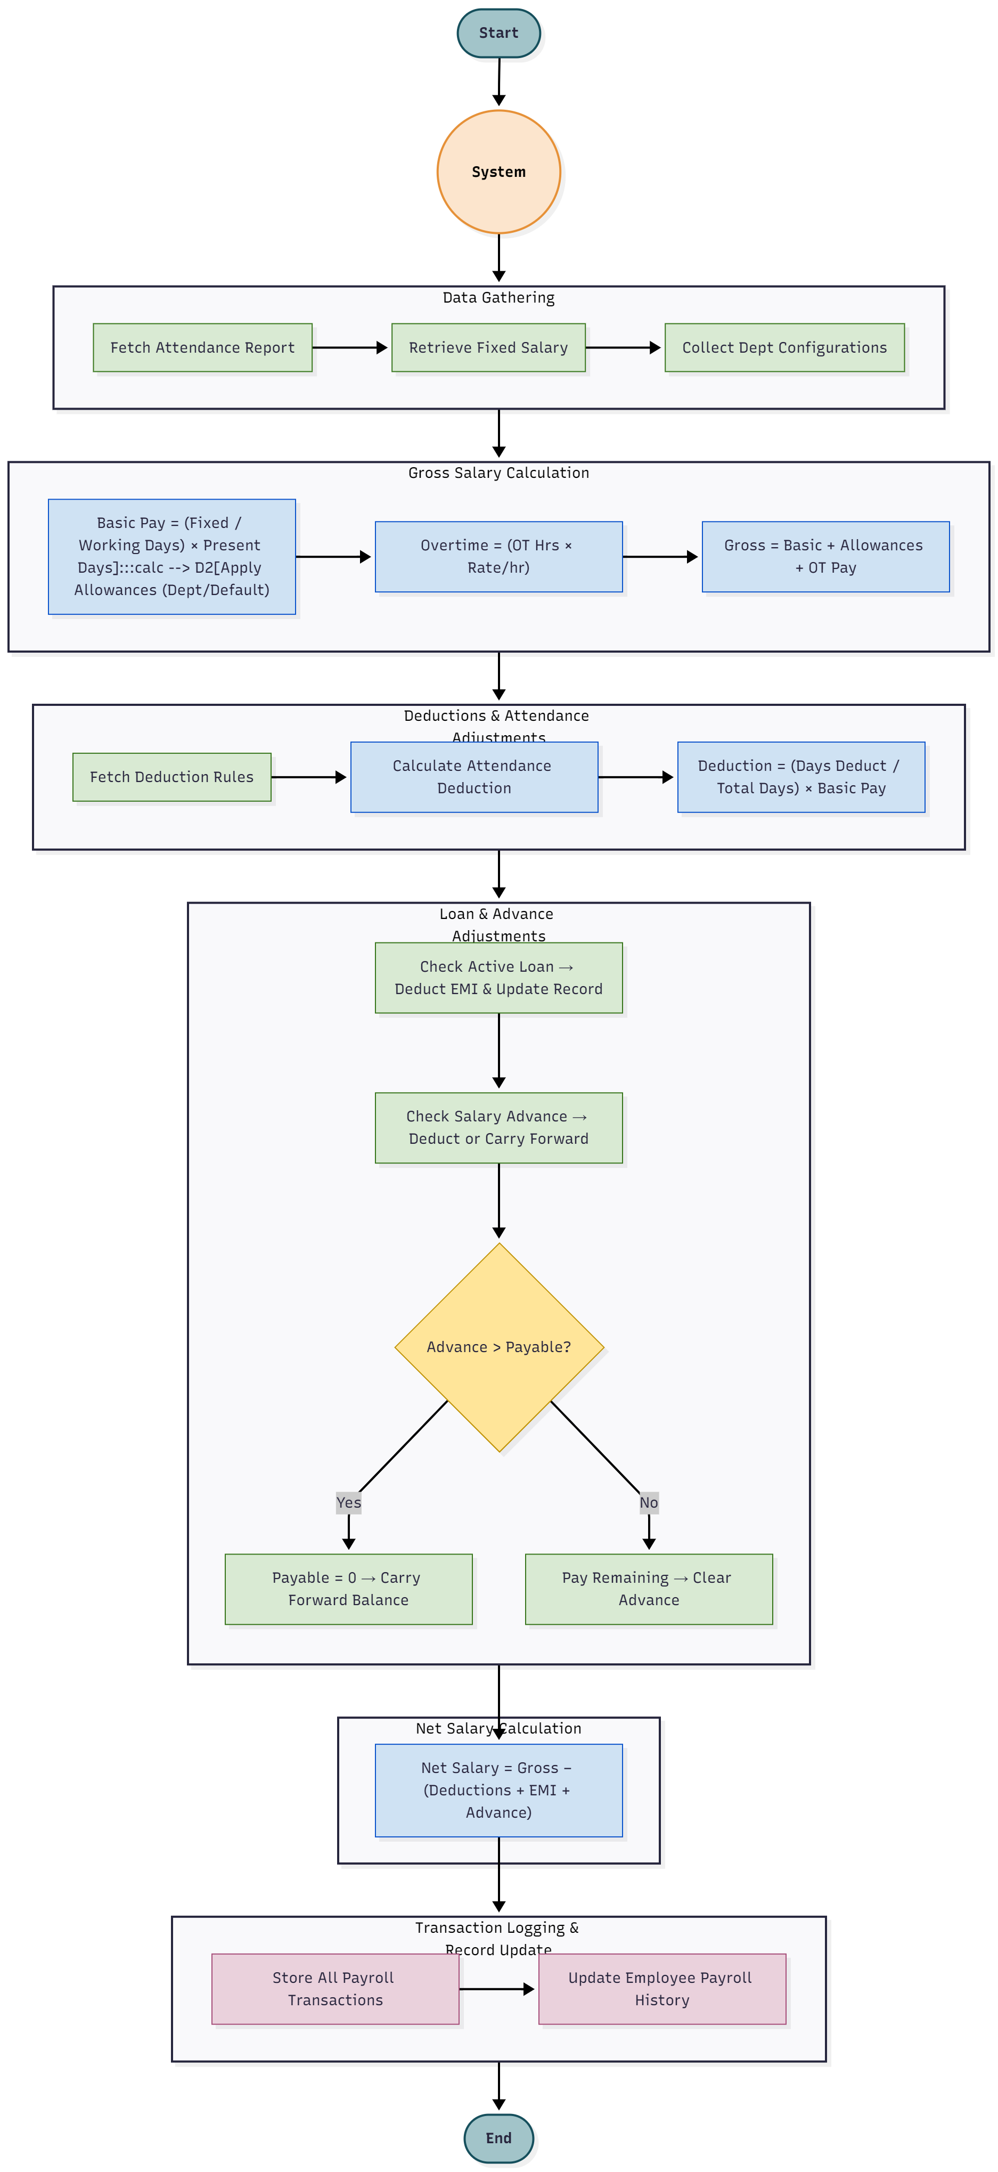

3.2 Loan & Salary Advance Workflow
This sub-module handles the application, approval, and management of employee loans and salary advances.
It ensures multi-level approval and automatic integration with the Payroll Engine for repayment tracking.

3.2.1 Workflow

1. Application Stage
- Initiated By: Employee
- Details Captured: Requested amount, reason, repayment duration (for loan), and remarks.
- Approval Flow:
Employee → HOD → HR → (Optional) Super Admin

2. Approval Stage
- HOD verifies justification and forwards to HR.
- HR or Super Admin finalizes approval and disburses the amount.
- Upon approval:
  - For Loans: EMI amount, start date, and total months are configured.
  - For Salary Advance: Amount deducted directly from next payroll cycle(s).

3. Repayment Tracking
- Every payroll cycle:
  - Loan EMI automatically deducted.
  - Salary advance balance reconciled.
- Transactions recorded in the system for full traceability.

4. Configuration Options
- Super Admin/HR can configure:
  - Maximum loan and advance limits.
  - Interest rate (if applicable).
  - Repayment duration and rules.
  - Department/designation-wise eligibility.
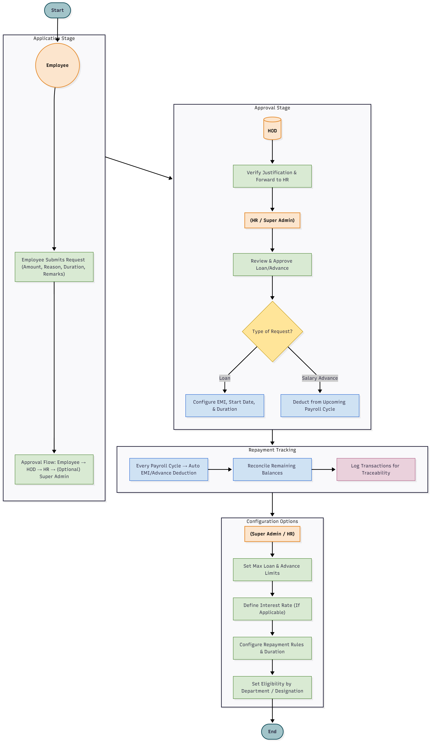

4. Conclusion
The HRMS & Attendance Management System delivers a fully automated, integrated, and scalable solution to manage human resources across the organization. By combining attendance tracking, user management, and payroll processing under one unified platform, it minimizes manual effort, enhances accuracy, and improves transparency across all HR operations.
The system’s modular structure — Attendance, User Management, and Payroll — ensures flexibility and ease of maintenance while allowing each department to configure rules according to their policies. Seamless integration between modules guarantees that every attendance record, leave request, and overtime entry is accurately reflected in payroll computation.
In addition, configurable workflows, role-based permissions, and real-time analytics make this solution adaptable to diverse organizational hierarchies and operational needs.

5. Key Outcomes
- Automation: Eliminates manual HR processes and human errors.
- Transparency: Every action is logged, traceable, and auditable.
- Scalability: Can accommodate growth in workforce and departments easily.
- Integration: Attendance, payroll, and permissions are fully synchronized.
- Flexibility: Supports configurable rules, multiple shifts, and approval hierarchies.

